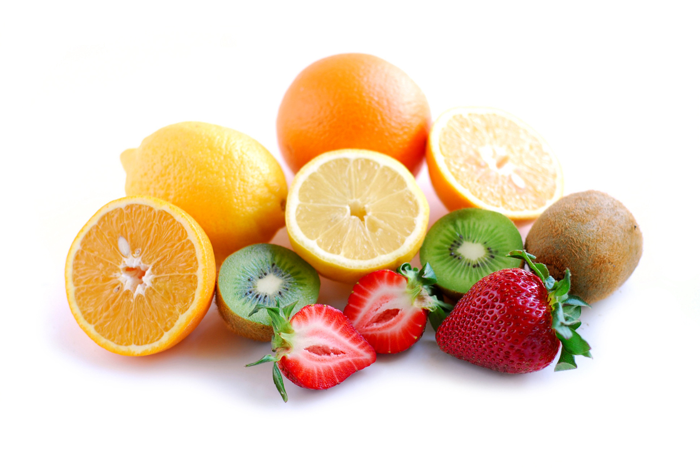
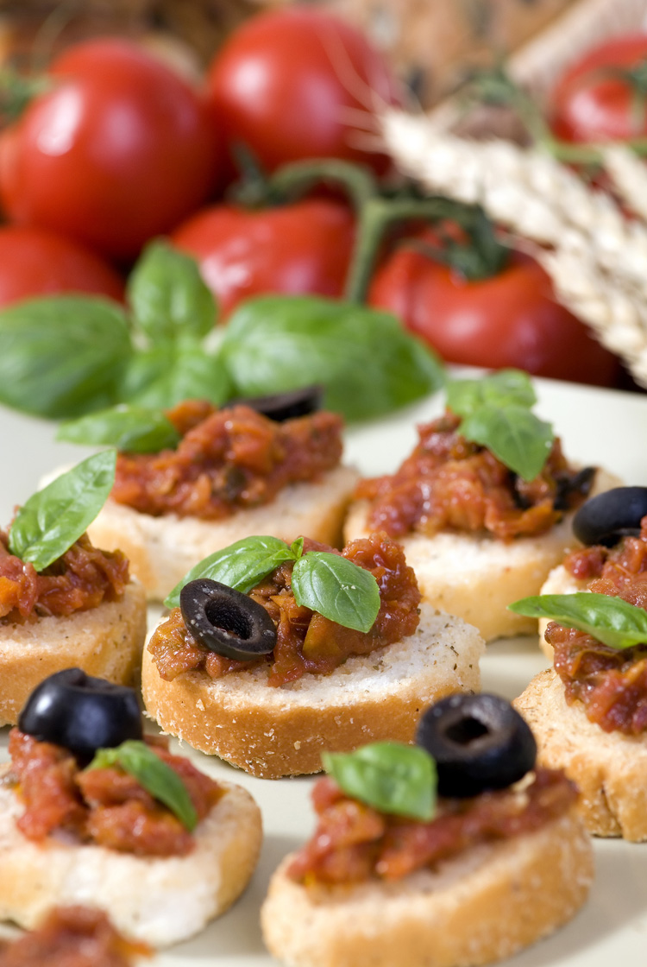
Lunch Menu
Week 3

Days | AM  Snack | Starter | Main Meal | Dessert | PM  Snack
Monday | Oatcake,  cheddar cheese & apple |  | Quorn goujon, herb or plain potatoes wedges & fresh vegetables | Yoghurt | Chicken morning roll &  banana
Tuesday | Lemon and sultana muffin & green grapes | Soup | Lasagne, crusty bread & seasonal vegetables |  | Cheese sandwich &  cherry tomato
Wednesday | Banana roll &  melon | Soup | Chicken, yorkshire pudding, potatoes & seasonal vegetables |  | Breadsticks, carrot & cucumber dip & banana
Thursday | Tuna sandwich  & green apple |  | Sausages in gravy, potatoes  & seasonal vegetables | Fruit | Fromage frais &  orange
Friday | Banana loaf & easy peeler | Soup | Fish cake, potato wedges & seasonal veg |  | Pitta bread  cheese spread & red apple

