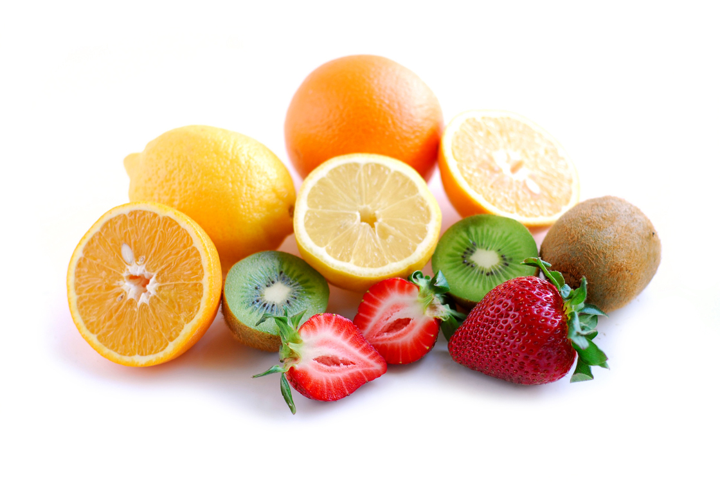
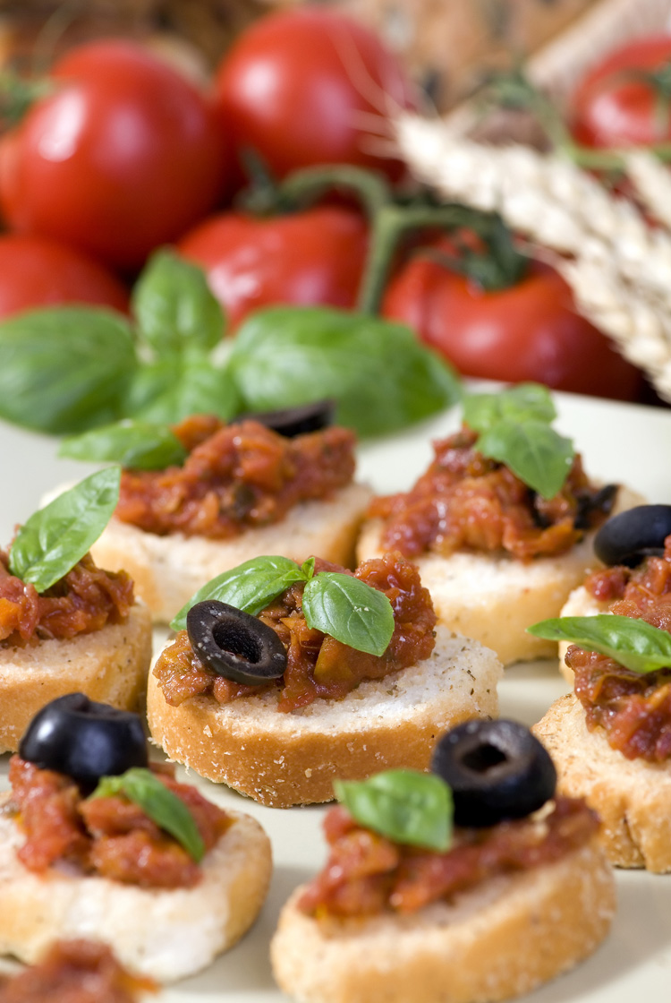
Lunch Menu
Week 2

Days | AM  Snack | Starter | Main Meal | Dessert | PM  Snack
Monday | Breadsticks, carrot & cucumber,  yoghurt dip & banana | Soup | Baked potato, cheese, coleslaw & side salad |  | Cheese roll & cherry Tomato
Tuesday | Crumpet & red grapes |  | Savoury mince, potatoes & seasonal vegetables | Fruit | Chicken morning roll & red grapes
Wednesday | Pitta bread,  cheese & green apple |  | Quorn meatballs in gravy, spiced or plain diced potatoes & vegetables | Yoghurt | Fromage frais & banana
Thursday | Banana roll & melon | Soup | Spaghetti bolognaise, crusty bread & fresh vegetables |  | Fairy cake & grapes
Friday | Turkey roll & cherry tomatoes | Soup | Fish fingers, potatoes and seasonal vegetables |  | Crackers, cheddar cheese & red apple

