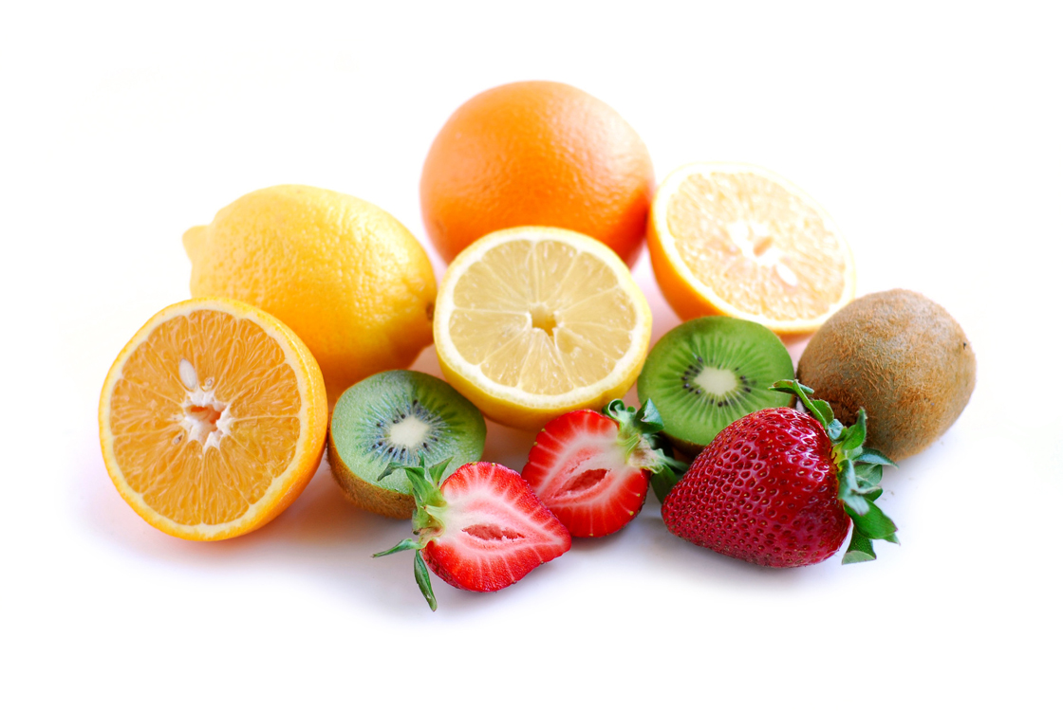
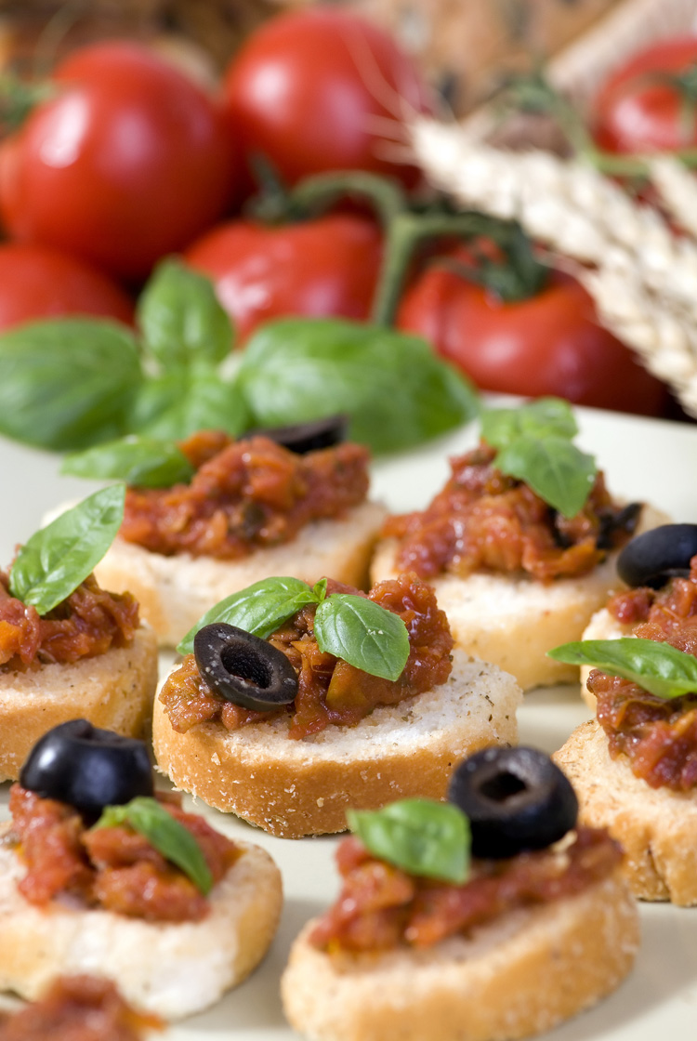
Lunch Menu
Week 1

Days | AM  Snack | Starter | Main Meal | Dessert | PM  Snack
Monday | Cream cracker,  cheese & orange | Soup | Quorn meatballs in tomato sauce with rice and vegetables |  | Fromage frais & green apple
Tuesday | Banana roll & grapes |  | Roast chicken, yorkshire pudding with potatoes & seasonal vegetables | Fruit | Breadstick, carrot & cucumber,  yoghurt dips & easy peeler
Wednesday | Pitta bread, cheese &  melon | Soup | Fish fingers with potatoes and seasonal vegetables |  | Chicken roll & red grapes
Thursday | Banana loaf & green apple |  | Steak pie with potatoes and seasonal vegetables | Yoghurt | Oatcake,  cheddar cheese & melon
Friday | Crumpet & green apple | Soup | Chicken curry with rice & fresh vegetables |  | Turkey sandwich & banana

