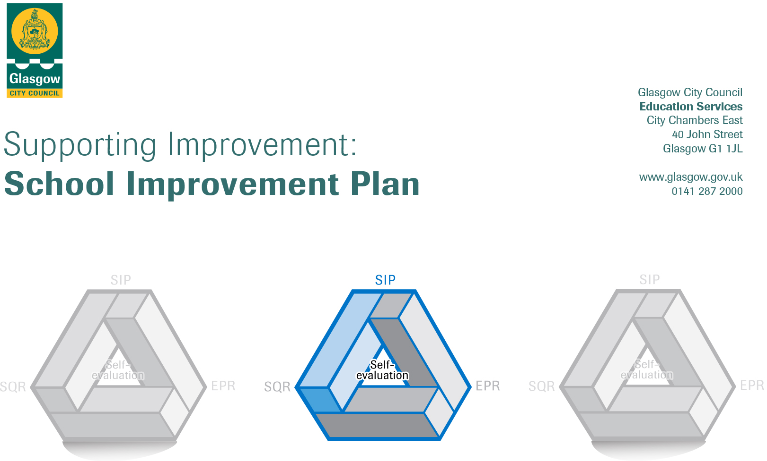

Session: 2017-18

Establishment |  | Govan Family Learning Centre
Head of Establishment |  | Catherine Leese
Area/Local Improvement Group |  | Govan-Bella Lig 2
Head of Service |  | Annemarie McGovern
Area Education Officer/  Quality Improvement Officer |  | David Byrne

CONTENTS
1. Vision, Values and Aims
2. Summary of Self-Evaluation Process / Priorities for Improvement in the current session
3. Action Planning

Action Plan Summary for Stakeholders

1. Our Vision, Values and Aims
At Govan Family Learning Centre we provide a safe stimulating inclusive and nurturing environment. Everyone involved in the life of the centre will be valued, treated with respect and motivated and challenged to maximise their potential. We promote positive partnership links with our families and the community by welcoming all young children and adults where individuality, diversity and equality are valued.
We aim to:
- Provide a safe, stimulating learning environment, both inside and outdoors that nurtures and empowers each child, respects their individuality, builds their self-esteem, values and celebrates their individual achievements and successes.
- To match learning opportunities to the needs of the children.
- To teach and support each child sensitively and to make learning fun.
- To value the role of the parents/carers and to work closely with them and others to provide the best start in life for children.
- Use a holistic approach to encourage, and where possible support, adults to explore opportunities for learning.
- To promote health and wellbeing through a healthy balanced diet, and offer a wide variety of opportunities for children to explore emotions and enjoy exercise and physical activity.
- We strive to reduce inequality and encourage all service users to show respect towards others and the environment.
Our Values:
- Learning, Trust, Friendships, Respect and Kindness.
2. Summary of our self-evaluation process.
In the past year there have been a number of changes within the staff team at Govan Family Learning Centre. Therefore, the centres Vision, Values and Aims (VVA) required reviewing so that all practitioners shared our vision of how to provide high quality early learning and child care. At a recent in service day all practitioners had the opportunity to read, review and discuss in length the current VVA. This gave new members of the team the opportunity to understand the current VVA and also to contribute their views and expectations of a high quality early learning and childcare service. This allowed a whole team approach to developing a newly revised VVA which was used alongside our completed monitoring and self-evaluation evidence to develop our improvement plan for 2017-2018. Whilst completing this task practitioners were given opportunities to research and discuss various documents, guidelines and policies such as 'Building the Ambition and ‘How good is our early years centre’. Once completed we displayed our VVA on the notice board for a consultation period allowing parents to express their views and opinions. We intend to revisit the statement annually, giving new practitioners, parent and carers an opportunity to contribute and have ownership of the VVA of Govan Family Learning Centre
Strengths identified:
A forward planning monitoring and evaluation calendar is in place based on the document “How Good is Our Early Learning and Childcare, and is completed in partnership with practitioners and all service users. We develop and distribute questionnaires to all service users termly or as required, and use all feedback to evaluate our practice and improve the quality of the service we provide. We also have several other sources of evidence that we regularly monitor and use to evaluate practice such as children’s learning journals, personal plans, curriculum planning formats, tracking formats, minutes from meetings, video footage, photographs and transition records which all help us to evaluate our service. There is also a suggestion box situated in our reception area for all users and a noticeboard for parents/cares in the corridor and at the main entrance to ensure users are fully involved in the life of the service, and included in the learning being delivered. We also work closely with communities of practice within our LIG quad group (Festival Park Day Nursery, Broomloan Rd Nursery and Nitsdale Rd Nursery) to moderate most aspects of practice so that we can improve outcomes for children and families. All of these strategies have enabled us to identify our strengths and achievements, which include funding awards and various accreditations. We use all feedback gathered from the above strategies alongside Glasgow City Councils objectives to develop an improvement plan which focuses on improving areas of development highlighted.
Priorities for development:

1: Review planning formats in relation to Curriculum for Excellence, Pre Birth to 3 & Building the Ambition.

2.Self-Evaluation for self-improvement

3: To promote a holistic approach to Family Learning.

4: Using Digi-learning to support raising attainment in Numeracy, Literacy and Health & Wellbeing.

No. | Quality Indicator | Priority
1 | 1.1  2.2  2.3 | To review and develop current planning formats related to Curriculum for Excellence (CfE), Pre-Birth to Three and Building the Ambition
Tasks to achieve priority | Timescale  and checkpoints | Evidence of Impact > (data, observation, views)
Complete a SWOT Analysis of current system. | September 2017 | Completed SWOT analysis, Minutes from team meetings, completed self-evaluation and monitoring pro forma.
Use completed self-evaluation and monitoring pro-forma to highlight where and what changes are required. Discussions to be held with all teams to reflect on what is working well and what needs adapted | October 2017 | Identify improvement required. Identify areas of curriculum and guidelines which are not currently being met and identify areas which are highlighting strengths.
Use research as a tool for identifying new strategies that will improve positive outcomes for all learners. | October 2017 | Purchase books from Amazon relating to Assessment, Observations and planning for all staff to access. Staff plans to use their CPD hours to read and then have professional dialogue within their staff teams.
All staff receive 17.5 hours CPD (training) from our employer, this is also a requirement for our SSSC registration. LTS website is accessed by all staff. Research should focus on individual learning, purposeful observations, the importance of the environment and schemas | Aug-June 17-18 | Ensure practitioners have opportunities to read research gathered and provide feedback. Source and attend training events related to the observations, Assessment and planning
Ensure guidelines from “A Statement for Practitioners from HM Chief Inspector of Education” are being implemented in new planning formats. | December 2017 | Paperwork to support their findings will be developed to support children’s individual learning needs within the nursery centre.  Training on Assessment has been identified and all staff will attend.

Staff leading on this priority – including partners | Resources and staff development
Head of Centre, Depute and Team Leader will support all staff teams within the nursery.  Leader of Learning will work in partnership with all staff.  Parents and children for trial period using the learning journals. | - Learning Teaching Scotland Website.  - A of reading resources to support staff with professional dialogue.  - Learning Journal website.  - Paperwork designed and implemented by all staff.  - Learning Journal website.
No. | Quality Indicator | Priority
2 | 1.1 | Self-Evaluation for self-improvement

Tasks to achieve priority | Timescale  and checkpoints | Evidence of Impact > (data, observation, views)
All parents and users of our establishment will be issued with our end of term self-evaluations. Parents have opportunities throughout the school year to have formal and informal discussions with all staff. | June- Sept 2017 | Use completed self-evaluation and monitoring pro-forma to highlight where and what changes are required. Children and their families’ views will be effectively used to improve the life of the nursery setting.
All results will be issued to parents; we will also display the results onto our information wall in the corridor. | September 2017 | Discussions to be held with all teams to reflect on what is working well and what needs adapted
Self-evaluation Calendar created to include HGIOELC quality indicators. | August 2017 | We will use the calendar to ensure that we are keeping up to date to provide a great service.
All staff will be included with all new areas requiring development and improved within the nursery. We require a whole team approach for our service users. Staff will reflect and share their own practice taking forward agreed areas for improvement.  HGIOELC document will be referred to and staff will include the quality indicators into their long term planning. | Aug-June 18-17 | In-service days and staff CPD training will be identified and accessed to coincide with our improvements.  All staff will ensure that they read the challenge questions as they address the quality indicators. They will use the inward, outwards and forwards approach discussed in the document.

Staff leading on this priority – including partners | Resources and staff development
Head of Centre  Depute, Team Leader  Child development officers  Parents  Third sector | How Good Is Our Early learning and childcare document  Health and Social Care Standards  Evaluations for different points within the school year,  Moderation cycle toolkit  Learning teaching Scotland Hub.

No. | Quality Indicator | Priority
3 | 2.5  2.7 | To promote a holistic approach to Family Learning

Tasks to achieve priority | Timescale  and checkpoints | Evidence of Impact > (data, observation, views)
Love Learning Scotland who is a training provider for Parents to access PDA 2: qualification whilst carrying out a project within the family centre has approached HOC to commence a group. | June 2017 | Information has been gathered from the company, price, course details and length of the course, this will enable us to work in partnership and provide further learning and support for parents. Approaches seek to include all, especially those who may face barriers to be involved.
Funding applied to ‘Parents in Partnership’ this will allow us to access training for parents within the centre and the community the course will cost £5,600.00 for 16 parents to attend. | July 2017 | Parent and Partnership funding is available from GCC. Maureen McKenna decides on each individual application. This project will promote equality and diversity. Parents will graduate after the course and they will receive a PDA level 2: qualification; which will allow them to add their CV or allow them to begin training at college.
Outdoor learning has been chosen as our project focus. The parents and staff who participate will attended for 10 weeks, each week the focus will be on a different subject but will incorporate the curriculum for excellence, building the ambition, GIRFEC, first Aid, health & Safety, My World outdoors publication from care inspectorate and there will be a few hours allocated for parents to discuss issues that they want incorporated to assist them at home. | Sept 17 | Parents involved will plan the project. This will include literacy and numeracy with health and wellbeing as they learn about the importance of the outdoor play environment and the benefits to their children and families it can bring. Each week tasks will be completed to the course leader’s criteria. This will ensure they have a purpose, aim, roles and responsibilities and that they are clear and understood within the group.
Outdoor fairy garden will be developed as parents share their skills and knowledge and make improvements for children. Joint planning and evaluations of partnership working will show the positive difference collaboration can make to the children’s outdoor play area. | Nov 17 | Staff will assist on the course to ensure the project continues after the 10 weeks, this will ensure sustainability. Partnership working with other agencies and families will demonstrate the improvements for all involved at the nursery centre.
Staff leading on this priority – including partners | Resources and staff development
Love Learning Scotland Company.  Glasgow City Council for funding.  Head of Centre, Depute. | Funding,  Outdoor area and playroom for parents and course leader to complete their project. £1000.00 for resources.  Documents for parents to access and read, CfE, BTA, GIRFEC and My Outdoor World.

No. | Quality Indicator | Priority
4 | 2.2  3.3 | Using Digi-learning to support raising attainment in Numeracy, Literacy and Health & Wellbeing

Tasks to achieve priority | Timescale  and checkpoints | Evidence of Impact > (data, observation, views)
Application to Big lottery funding for ICT resources. | Aug 2017 | We have requested for £10,000. To purchase ICT resources for all users of the building. Lap tops and a promethean board, talking books and remote controlled equipment. I pads or Tablet devices.
Purchase Learning Journal format for all staff to record children’s learning within the Centre. All parents receive a unique password to access the secure website. Identify Parent and children to participate with trail on their child’s learning journal. | October 2017 | Parents will be able to keep up to date with their child’s learning, Observations, assessment and their daily diary. Parents will also be able to contribute to the files with photographs and comments on their child’s home life.
Monitoring of staff‘s usage, parent and the children feedback will be consulted on by the management team after the pilot scheme. | November 2017 | The management team will be able to track all staff and parents who are using the site. We will be able to gather quantitive data and feed this back to all users of the nursery centre.
All staff to receive an I pad or tablet device to assist with planning. | November 2017 | All staff will be able to use their own device for our learning journals.
ICT resources to be identified and purchased. All resources will be augmented into our existing resources. We will consult with our parents and ask for any ideas or new technologies they have seen for their child. | January 2018 | The Children and staff within the nursery will be consulted on what new ICT resources they would like to have. These items will be purchased through educational catalogues and added to our existing equipment. The children’s learning will be scaffolded to use technology appropriately where they will be able to solve a range of problems with confidence.
School website will be piloted and designed using Gateway. Our leader of learning will design this page with Jane Fraser our clerical assistant. | November 2017 | Martin, Jane and Karen will create the web page with the assistance of Gateway. Parents will be involved with the page and usage will be monitored by the business manager to ensure sustainability for the centre.

Staff leading on this priority – including partners | Resources and staff development
Management team within the nursery.  All child development officers  Parent to participate.  Children within the centre.  Martin McGinn, Jane Fraser. | Learning journal website.  Funding sources for resources for all users. ICT resources identified and purchased.  All staff and parents to be informed on how to use the learning journal.  Gateway project for the website.

